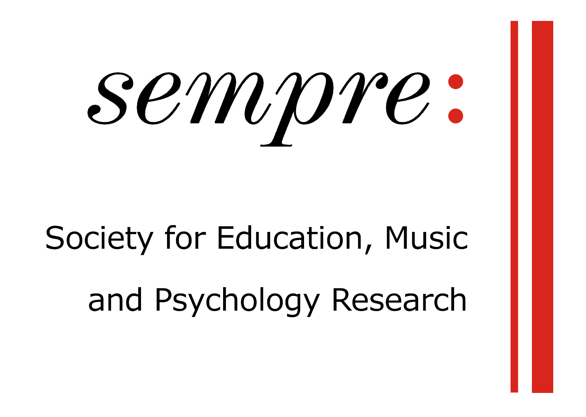

Autumn 2020 SEMPRE Conference
The role of music psychology research in a complex world:
Implications, applications and debates

9–11 September, 2020
School of Music, University of Leeds

Provisional conference schedule
Day 1: Wednesday 9 September

13:00–13:15 | Welcome
13:15–14:15 | Session 1: Social Justice
Still we rise: Racial discriminatory resilience and Black American musicians
Clarke Randolph (Royal College of Music)

Social justice and the orchestra industry
Cayenna Ponchione-Bailey (University of Oxford)

14:15–14:45 | Break
14:45–15:45 | Can music psychology research help us to address the climate crisis?  Helen Prior (University of Hull)  Music for social change: Evidence from social neuroscience, cultural conflict, and big data  David Greenberg (Bar-Ilan University)
15:45–16:15 | Break
16:15–17:45 | Session 2: Education
Capturing children’s social connections: A new method to examine the relationship between music tuition and social experiences
Kate Cameron (University of Leeds)

Creative arts in secondary education: A study of predictors and implications of creative subject choices
Maruša Levstek (University of Sussex)

How do we motivate young musicians to persist in musical learning despite current educational pressures?
Samantha Caffull (University of York)

Day 2: Thursday 10 September

13:00–14:00 | Session 3: Methods in Applied Contexts (1)
Exploring the potential for music psychologists working as researchers in residence in UK care homes
Jessica Crich (University of Sheffield)

How participatory music engagement supports mental health: Reflecting on the process and findings from a meta-ethnography
Rosie Perkins (Royal College of Music / Imperial College London), Adele Mason-Bertrand (Royal College of Music / Imperial College London), Daisy Fancourt (University College London), L Baxter (University College London), and Aaron Williamon (Royal College of Music / Imperial College London)

14:00–14:30 | Break
14:30–15:30 | Session 4: Technology
Development of augmented reality environments for addressing musical performance anxiety
Nery Borges and Mário Vairinhos (University of Aveiro)

Virtually together: Concerts during the coronavirus
Dana Swarbrick, Beate Seibt, and Jonna Vuoskoski (University of Oslo)

15:30–16:00 | Break
16:00–17:00 | Session 5: Covid-19
Can music engagement provide a sense of social cohesion or social surrogacy during times of physical distancing?
Claire Howlin (University College Dublin), Will Randell (University of Jyväskylä), Lindsay Warrenburg (University College Dublin), Lauren Fink (Max Planck Institute for Empirical Aesthetics), Melanie Wald-Fuhrmann (Max Planck Institute for Empirical Aesthetics), and Niels C. Hansen (Aarhus University)

Music as a tool for emotional coping during the Coronavirus crisis
Lauren Fink (Max Planck Institute for Empirical Aesthetics), Claire Howlin (University College Dublin), Will Randell (University of Jyväskylä), Lindsay Warrenburg (University College Dublin), Niels C. Hansen (Aarhus University), and Melanie Wald-Fuhrmann (Max Planck Institute for Empirical Aesthetics)

17:00–17:30 | Break
17:30–18:30 | Invited speaker: Alexandra Lamont (Keele University)

Day 3: Friday 11 September

13:00–14:30 | Session 6: Health and wellbeing
Health and wellbeing in higher education: Challenges for music and sport
Elena Alessandri (Lucerne University of Applied Sciences and Arts), Dawn Rose (Lucerne University of Applied Sciences and Arts), and David Wasely (Cardiff University)

Mapping music for wellbeing in Sheffield
Ioanna Filippidi, Nicola Pennill, and Renee Timmers (University of Sheffield)

Understanding ‘musical vulnerability’ as a lens on music’s role in education, health, and wellbeing
Elizabeth H. MacGregor (University of Sheffield)

14:30–15:00 | Break
15:00–16:00 | Session 7: Methods in Applied Contexts (2)
Building musical lives: An ecological model for music intervention and support with autistic children and their families
Caitlin Shaughnessy (University of Roehampton)

The illusion of choice can increase pain threshold: Isolating the role of agency in music listening interventions
Claire Howlin and Brendan Rooney (University College Dublin)

16:00–16:30 | Break
16:30–18:00 | Session 8: Musical training
Tosca or Tesco: Exploring the career-building process for conservatoire graduates
Kate Blackstone (University of Leeds)

Associations between musical sophistication and personality: Evidence from three countries
Nicolas Ruth (Goldsmiths, University of London), Elina Tsigeman (Sirius University of Science and Technology, Sochi), Maxim Likhanov (Sirius University of Science and Technology, Sochi) , Yulia Kovas Sirius (Goldsmiths, University of London / University of Science and Technology, Sochi), and Daniel Müllensiefen (Goldsmiths, University of London)

Applying music psychology to address engagement issues in entrepreneurship
Sylvia Jen (University of Salford)

18:00–18:15 | Plenary wrap-up
 | Conference ends

