

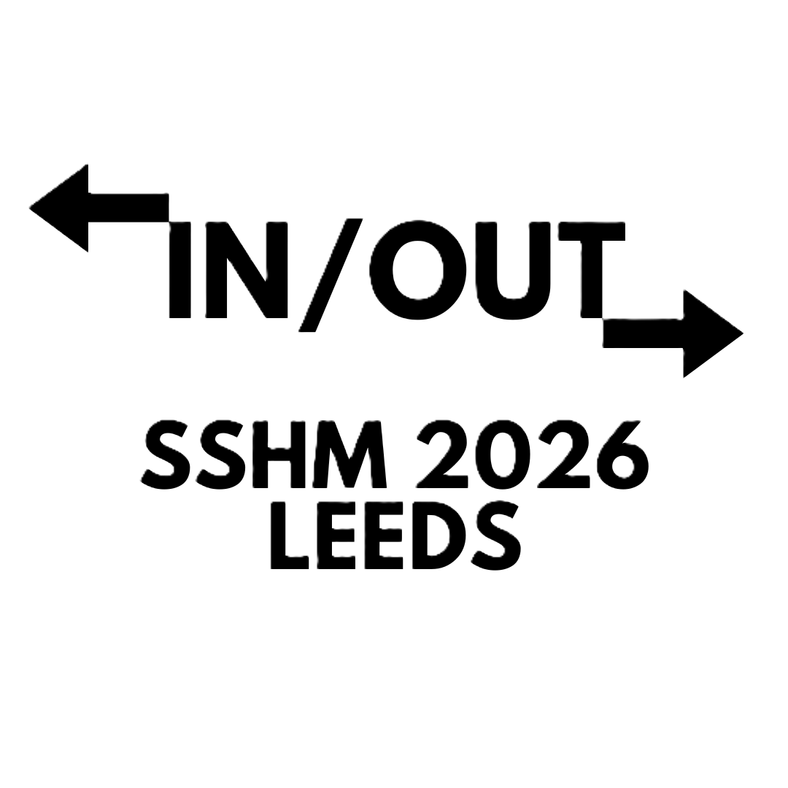

University of Leeds
30 June – 3 July
Useful Information for Participants

General Information

Spaces for Work and Rest
Need somewhere to catch up on emails? Or to collect your thoughts before or after your paper? Here are some suggestions:
- The ‘well’ area behind the Rupert Beckett Lecture Theatre – has tables and chairs for individual/group work. Michael Sadler Building Lower Ground Floor (street access level).
- The School of History Foyers on Level 3 of the Michael Sadler Building. There are two. Hamilton Thompson (left when exiting lifts/main stairs) has sofas for a comfortable spot to sit and Turberville (right when exiting lifts/main stairs) has tables and chairs for laptop working.

Designated Quiet Space
The Grant Room in the School of History (Michael Sadler 3.11) has been designated as a quiet space for those who wish to access a low-stimulation environment. Turn left when exiting the lift/stairs and keep going through doors until you cannot go any further. The room is on your right.

Water Fountains
The University of Leeds has over 200 water fountains located around its facilities, giving you access to fresh, free drinking water whenever you need it. Don’t forget to bring your fillable water bottle. To find your closest water fountain, use our Campus Map. You can find water fountains in many buildings on campus. If you’re unsure, the building’s reception area will be able to advise. You can access outdoor water fountain on the University Precinct (located outside the Refectory) 24/7.

The closest water fountains to where we will be are behind the Rupert Beckett Lecture Theatre and near the café on the ground floor of the Parkinson Building (Parkinson Court North).

Green Spaces

On Campus
- St George’s Field between Cemetery Road and behind the Henry Price flats (halls of residence) is a peaceful green space on campus. As the final resting place of Pablo Fanque, the UK's first Black circus owner, and his wives, Susannah and Elizabeth, St George’s is a Grade II listed historic memorial.
- Sensory Garden at Charles Morris Hall is a wheelchair-accessible garden located on campus. The garden has tactile plants, calming scents, and soothing sounds, perfect for if you need a little quiet time. Get accessibility information.
- Woodhouse Moor is a big green space located directly next to campus and popular with students during the summer months.

Further Afield
- Kirkstall Abbey is a ruined monastery a few miles from campus and the city centre. The Abbey dates back to 1152 but was put out of use by King Henry VIII in 1539. The Abbey itself is open Tuesday-Friday 10am – 4.30pm and operates a Give What You Can policy. Get accessibility information.
- Meanwood Park is a beautiful space to wind down and enjoy nature. The park is accessible from campus by bus (23, 24, 25 or 27) and a short walk. For delegates interested in the history of psychiatry, the Meanwood Park Estate previously housed Meanwood Park Hospital which operated under the Mental Deficiency, then Subnormality (1959) and Mental Handicap (1970s) acts in 20th century Britain. Get accessibility information.
- Roundhay Park is accessible by bus (X98 or X99) from the city centre. The 700-acre park features two lakes, Victorian follies and lots of greenery to sit back, relax and maybe even enjoy a picnic. Get accessibility information.

Local Food and Drink

On or Near the University of Leeds Campus:
- Coffee shops on campus include Parkinson Court Cafe, 1915 in the Bragg Building, Baines Wing Cafe and two Caffè Neros located on the ground floor of the Laidlaw Library or ground floor of the Roger Stevens Building.
- Miro has light lunch options and good coffee. It is located on Woodhouse Lane (opposite the Parkinson Building steps) and open from 8am on weekdays.
- Old Bar is Leeds University Union’s traditional pub. Serving students real ale and pub food since 1939, Old Bar is a lively yet cosy spot to walk-in and enjoy lunch, dinner or a drink. Old Bar is located downstairs in the University Union on campus and has some outdoor bench seating available. It is open from 11am on weekdays. Get accessibility information.
- Terrace offers indoor and outdoor seating for food and drinks on the ground floor of the Leeds University Union building. It is open from 11am on weekdays. Get accessibility information.
- Pickard’s is a lovely sandwich and coffee shop located on Woodhouse Lane (opposite the Parkinson Building steps). It is open 7am-5pm on weekdays.
- Lebanese Bites offers quick and delicious wraps, boxes and sides. Located on Woodhouse Lane (opposite the Parkinson Building steps) and open from 10.30am on weekdays.

In Leeds City Centre:

Coffee and Brunch
- Tiled Hall Café is a beautiful work-friendly cafe offering coffee, cake and light bites on the ground floor of Leeds Art Gallery. It is open from 10am on weekdays. Get accessibility information.
Average spend £1-10
- Laynes bakery, brunch and coffee is a lovely spot located right around the corner from Leeds Train Station.
Average spend £1-10
- La Bottega Milanese is an Italian coffee shop offering fantastic coffee and light bites. Open from 7.30am on weekdays.
Average spend £1-10
- IF at Leeds a chic walk-in brunch and coffee spot open from 8am on weekdays.
Average spend £10-20

Lunch and Dinner
- Street Food @ Kirkgate Market is one of the largest indoor markets in Europe. Opening in 1857 and later home to the first ever Marks & Spencer trading stall, today the bustling street food scene at the market offers a wide range of dining options including Vietnamese staples (a must-try is the roasted pork Banh and Mee), Indian classics, traditional fish and chips, Caribbean jerk chicken, Middle Eastern wraps, classic pizza slices, fried chicken and hot dogs. Open 8am until 5.30pm Monday to Saturday. Get accessibility information.
Average spend: £5-15
- White Cloth Hall is a trendy, modern market hall home to a bar and four independent food traders: Morty’s Focacceria, Salma Modern Mexican, Lupton’s Chop House and RAKKU East Asian Kitchen. It is conveniently located next to the Corn Exchange (see things to do) and is less than ten minutes from Leeds Train Station. Open Tuesday-Friday 12pm-11pm. Get accessibility information.
Average spend: £10-20
- Bundobust is a local gem known for its fantastic Indian street food and craft beer selection. All the food served here is vegetarian and walk-ins are welcome (though you can reserve a table to guarantee a spot). The restaurant is conveniently located just a one-minute walk from Leeds Train Station. Open every day from 12pm. Get accessibility information.
Average spend: £15-25
- Rudy’s Pizza (New Station Street) serves delicious, fresh Neapolitan pizzas in an informal restaurant setting. Walk-ins are welcome (though you can reserve a table online too) and service is usually quick. This restaurant is also conveniently located just a one-minute walk from Leeds Train Station. Open every day from 11.45am. Get accessibility information.
Average spend £15-25
- Belgrave Music Hall and Canteen offers fun, informal food and drink. The early-bird offers from Dough Boys and Patty’s Burgers ensure pizza slices (before 7pm) and burgers (before 6pm) are both tasty and wallet-friendly. Get accessibility information.
Average spend (early bird) £5-15

Drinks
- Leeds has many great spots to enjoy a drink after a long day of conferencing. If you are after something traditional and reliable, you could try Whitelocks pub, Nation of Shopkeepers, Brewery Wharf Tavern, Lamb and Flag, Head of Steam or a short walk from the city centre the Highland Laddie. If you want a social atmosphere with lots of choice, we suggest trying Belgrave Music Hall and Canteen (rooftop), White Cloth Hall, Rinse Natural Wine, Headrow House (rooftop) or Green Room. If you want some late-night live music entertainment, you might want to check out The Domino Club or Smokestack.

Things to See and Do

On Campus
- Stanley & Audrey Burton Gallery and Cultural Collections @ Treasures of the Brotherton Gallery are both galleries that showcase items from the University library collections. Located on campus and free to the public, the galleries are open Tuesday–Saturday: 10am to 5pm.
- Our Public Art Trail takes between 90 minutes and two hours to see everything, but the route can be altered to suit you. Head outside and stroll across the open, green spaces of our University campus to see 21 art installations from names such as Henry Moore and Barbara Hepworth. To discover the inspiration behind each piece, and hear fascinating personal anecdotes from the artists, tune into our audio trail. Our collection of Public Art is free and accessible for you to enjoy.

Further Afield
- Leeds Corn Exchange is a historic commerce centre and living landmark in the city. First opened in 1863, it is now home to a host of independent shops, creative spaces and cafes. In the same area of the city centre are the Leeds famous shopping arcades – the most ornate of which is Victoria Arcade. Get accessibility information.
- Thackray Museum of Medicine is the UK’s largest independent medical museum. If you’re not already booked on SSHM’s private tour, feel free to have a wander around independently. Located next to St James’ Hospital at 141 Beckett Street, Leeds, LS9 7LN, it takes around 15 minutes to get to the museum by bus numbers: 6, 42, 49, 50 and 50A. Choose your own ticket price from £9 upwards. Open daily 10am–4pm (last admission 3.15pm). Get accessibility information.
- Leeds Art Gallery and the Henry Moore Institute next door are worth a visit if art is your thing. The gallery is open Tuesday-Saturday 10am-5pm and operates a Give What You Can policy. Get accessibility information.
- Leeds City Museum takes you through the city's 800-year history with hands-on and audio-visual displays, exhibitions and interactive games. Located in Millenium Square, the Leeds City Museum operates a Give What You Can policy and is open Tuesday – Friday: 10am – 5pm and Saturday & Sunday: 11am – 5pm. Get accessibility information.
- Royal Armouries Museum is a fun and free museum showcasing incredible objects from the world’s finest collection of arms and armour, spread over five floors at Leeds Dock. From the end of June, a new exhibition entitled Genghis Khan: How the Mongols Changed the World will be live for a small fee. Get accessibility information.

